Software Design and Modeling

Software structure

- Student searches for a book or e-book using the application interface (Frontend)

- Request goes to Backend

- Backend checks the Database for:
- book title
- author
- category
- availability status
- e-book availability

- Backend sends results back to Frontend

- Student selects a book

- Backend retrieves detailed book information from Database

- Frontend displays:
- book details
- availability
- borrowing status

- Student requests to borrow or reserve the book

- Request goes to Backend

- Backend verifies:
- user authentication
- borrowing opportunity
- book availability

- Backend stores borrowing or reservation information in Database

- Database updates book availability status

- Backend sends confirmation message to Frontend

- Student uploads study notes through the application interface (Frontend)

- Request goes to Backend

- Backend stores uploaded notes temporarily in Database with “Pending Review” status

- Admin reviews uploaded notes

- Backend updates note status:
- Approved
- Rejected

- Approved notes become visible to other students through Frontend

- Student accesses e-books

- Backend checks user permissions and e-book availability in Database

- Backend provides secure access to e-book content

- Librarian manages books through the system

- Backend updates:
- book inventory
- borrowing records
- return status
- reservations

- Admin manages users, notes, and system data through the administration panel

Component Diagram

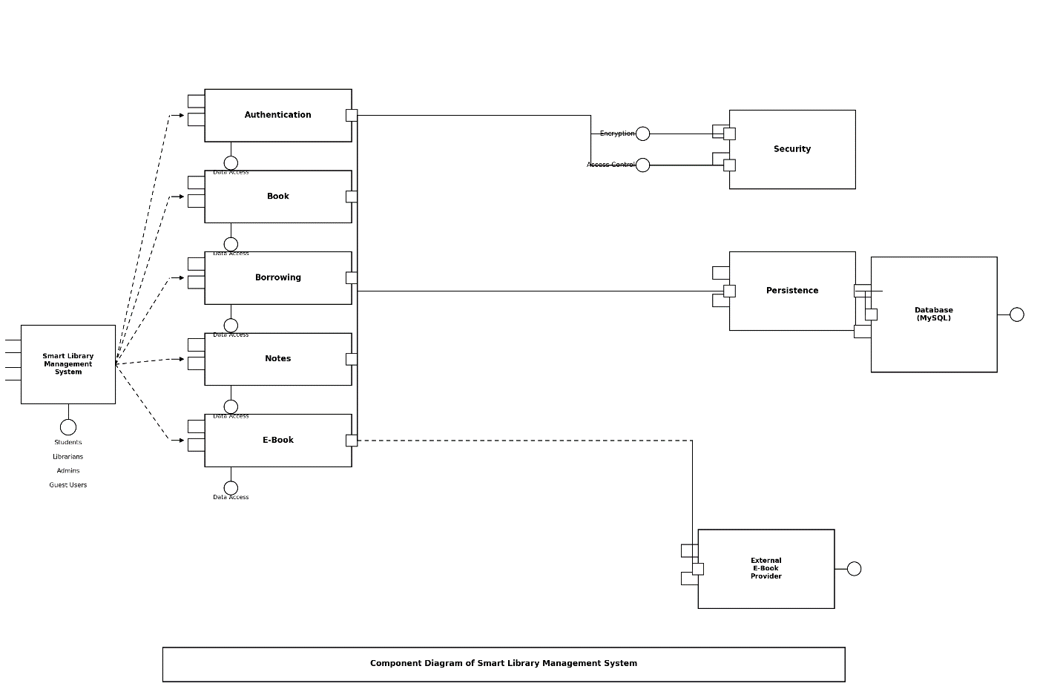

Actors (Left Side):
- Student — Represents a registered student user of the system.
- Librarian — Represents library staff who manage books and borrowing.
- Admin — Represents the system administrator who manages users and content.
- Guest User — Represents an unregistered visitor with limited access.
Components (Middle Part):
- Authentication — Handles user login, registration and authentication, meaning it verifies who is accessing the system.
- Book —Provides book records in the database like physical book details, categories and availability.
- Borrowing — Handles borrowing transactions, returning and extending books.
- Notes — Upload, download and provides organization of notes.
- E-Book — Reads and writes e-book records and also communicates externally with the External E-Book Provider through a dashed line.
Right Side:

- Security — Handles encryption, authorization and access control. It is connected with data access layer through encryption and access control nodes.
- Persistence — It is responsible for making sure data is correctly saved and not lost or corrupted.
- Database (MySQL) — Stores all system data including users, books, borrowings, notes and reservations. It connects from Persistence and data reaches the database after passing through the persistence layer.
- External E-Book Provider — Outside third-party digital library that provides additional e-book content and resources.

Class Diagram

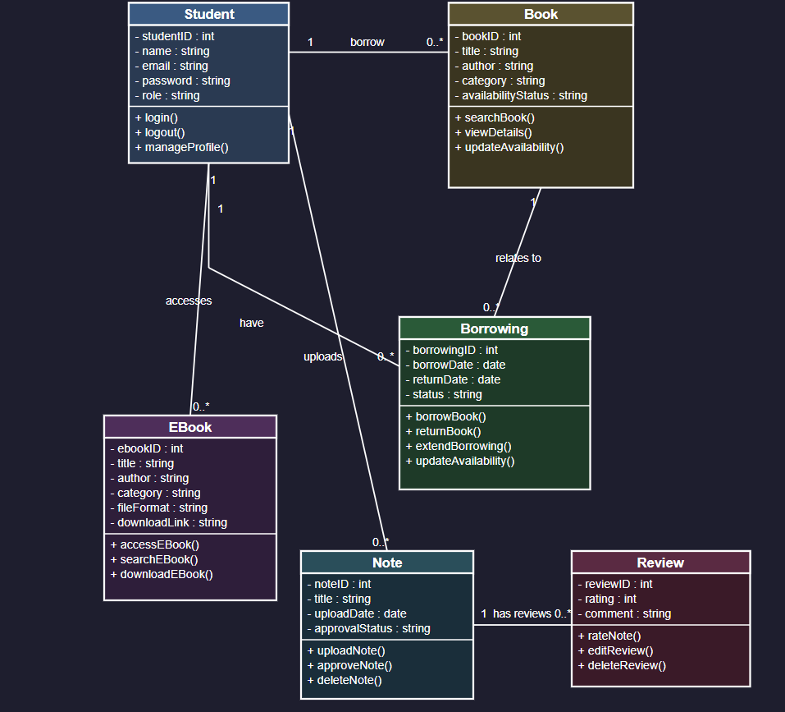

Relationships:
1. Student→ Book (1 to 0..*): A single Student can borrow zero or many Books.
2. Student → Borrowing (1 to 0..*): A single Student can have zero or many Borrowing records.
3. Book → Borrowing (1 to 0..*): A single Book can relate to zero or many Borrowing records over time.
4. Book → Reservation (1 to 0..*): A single Book can have zero or many Reservations.
5. Student→ E-Book (1 to 0..*): A single Student can access zero or many E-Books.
6. Student→ Note (1 to 0..*): A single Student can upload zero or many Notes.
7. Note → Review (1 to 0..*): A single Note can have zero or many Reviews.

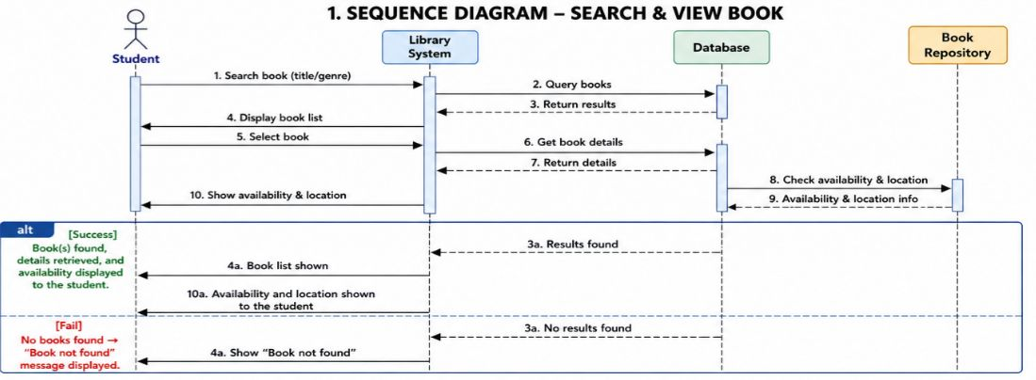

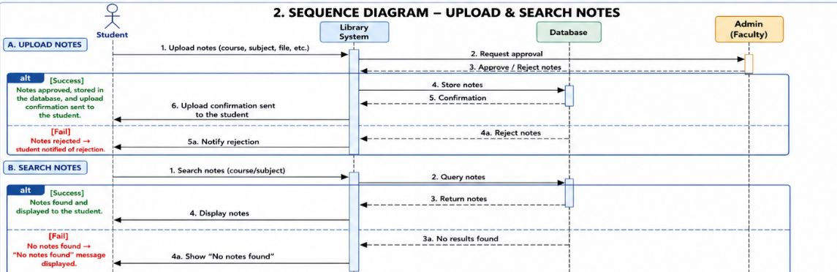

Use Case Diagram

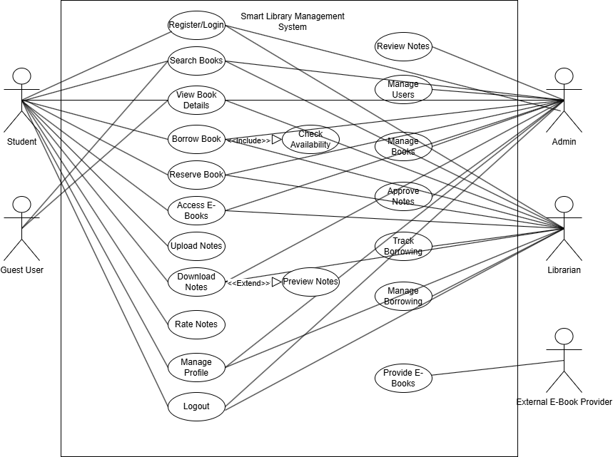

Activity Diagram

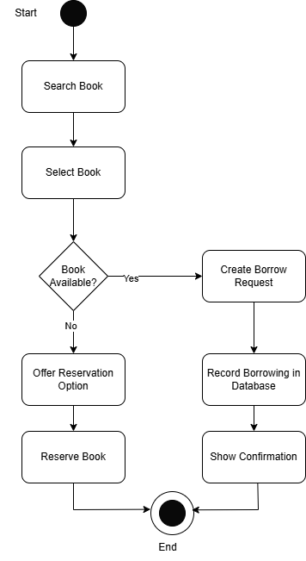

State Diagram
(Book)

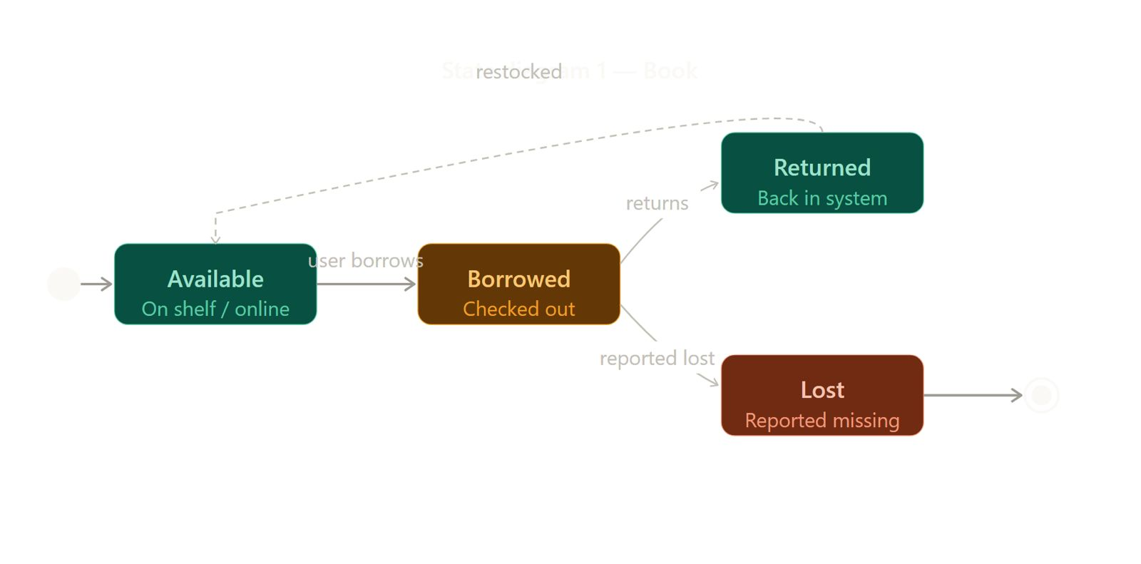

State Diagram
(Student Notes)

